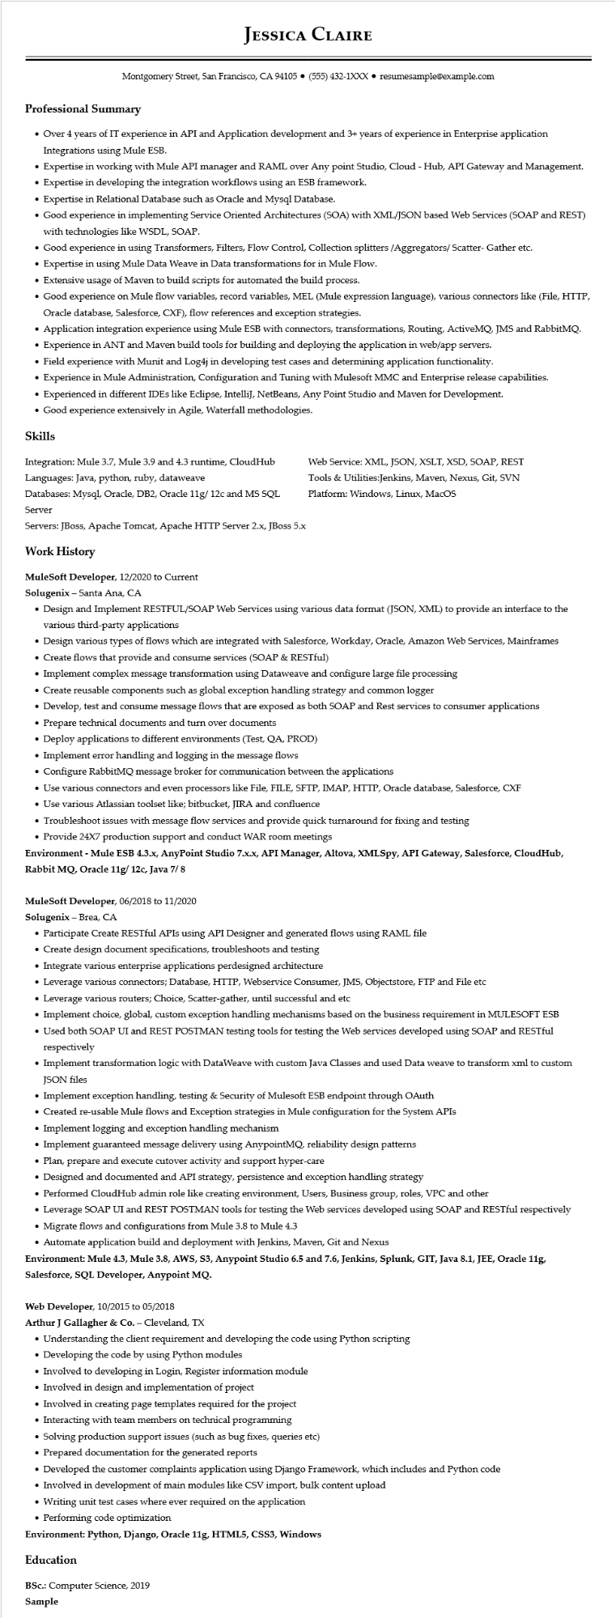
JESSICA CLAIRE
Montgomery Street, San Francisco, CA 94105 ⚫ (555) 432-1XXX⚫ resumesample@example.com
Professional Summary
• Over 4 years of IT experience in API and Application development and 3+ years of experience in Enterprise application Integrations using Mule ESB.
• Expertise in working with Mule API manager and RAML over Any point Studio, Cloud - Hub, API Gateway and Management.
·
Expertise in developing the integration workflows using an ESB framework.
• Expertise in Relational Database such as Oracle and Mysql Database.
• Good experience in implementing Service Oriented Architectures (SOA) with XML/JSON based Web Services (SOAP and REST) with technologies like WSDL, SOAP.
• Good experience in using Transformers, Filters, Flow Control, Collection splitters /Aggregators/ Scatter- Gather etc.
• Expertise in using Mule Data Weave in Data transformations for in Mule Flow.
• Extensive usage of Maven to build scripts for automated the build process.
• Good experience on Mule flow variables, record variables, MEL (Mule expression language), various connectors like (File, HTTP, Oracle database, Salesforce, CXF), flow references and exception strategies.
• Application integration experience using Mule ESB with connectors, transformations, Routing, ActiveMQ, JMS and RabbitMQ.
• Experience in ANT and Maven build tools for building and deploying the application in web/app servers.
• Field experience with Munit and Log4j in developing test cases and determining application functionality.
•
Experience in Mule Administration, Configuration and Tuning with Mulesoft MMC and Enterprise release capabilities.
• Experienced in different IDEs like Eclipse, IntelliJ, NetBeans, Any Point Studio and Maven for Development.
• Good experience extensively in Agile, Waterfall methodologies.
Skills
Integration: Mule 3.7, Mule 3.9 and 4.3 runtime, CloudHub Languages: Java, python, ruby, dataweave
Databases: Mysql, Oracle, DB2, Oracle 11g/ 12c and MS SQL Server
Servers: JBoss, Apache Tomcat, Apache HTTP Server 2.x, JBoss 5.x
Work History
MuleSoft Developer, 12/2020 to Current
Solugenix - Santa Ana, CA
Web Service: XML, JSON, XSLT, XSD, SOAP, REST
Tools & Utilities:Jenkins, Maven, Nexus, Git, SVN Platform: Windows, Linux, MacOS
• Design and Implement RESTFUL/SOAP Web Services using various data format (JSON, XML) to provide an interface to the various third-party applications
• Design various types of flows which are integrated with Salesforce, Workday, Oracle, Amazon Web Services, Mainframes
• Create flows that provide and consume services (SOAP & RESTful)
• Implement complex message transformation using Dataweave and configure large file processing
• Create reusable components such as global exception handling strategy and common logger
• Develop, test and consume message flows that are exposed as both SOAP and Rest services to consumer applications
• Prepare technical documents and turn over documents
• Deploy applications to different environments (Test, QA, PROD)
• Implement error handling and logging in the message flows
• Configure RabbitMQ message broker for communication between the applications
• Use various connectors and even processors like File, FILE, SFTP, IMAP, HTTP, Oracle database, Salesforce, CXF
• Use various Atlassian toolset like; bitbucket, JIRA and confluence
• Troubleshoot issues with message flow services and provide quick turnaround for fixing and testing
• Provide 24X7 production support and conduct WAR room meetings
Environment - Mule ESB 4.3.x, AnyPoint Studio 7.x.x, API Manager, Altova, XMLSpy, API Gateway, Salesforce, CloudHub, Rabbit MQ, Oracle 11g/ 12c, Java 7/ 8
MuleSoft Developer, 06/2018 to 11/2020
Solugenix - Brea, CA
• Participate Create RESTful APIs using API Designer and generated flows using RAML file
• Create design document specifications, troubleshoots and testing
• Integrate various enterprise applications perdesigned architecture
• Leverage various connectors; Database, HTTP, Webservice Consumer, JMS, Objectstore, FTP and File etc
• Leverage various routers; Choice, Scatter-gather, until successful and etc
• Implement choice, global, custom exception handling mechanisms based on the business requirement in MULESOFT ESB
• Used both SOAP UI and REST POSTMAN testing tools for testing the Web services developed using SOAP and RESTful respectively
• Implement transformation logic with DataWeave with custom Java Classes and used Data weave to transform xml to custom JSON files
• Implement exception handling, testing & Security of Mulesoft ESB endpoint through OAuth
• Created re-usable Mule flows and Exception strategies in Mule configuration for the System APIs
• Implement logging and exception handling mechanism
• Implement guaranteed message delivery using AnypointMQ, reliability design patterns
• Plan, prepare and execute cutover activity and support hyper-care
• Designed and documented and API strategy, persistence and exception handling strategy
• Performed CloudHub admin role like creating environment, Users, Business group, roles, VPC and other
• Leverage SOAP UI and REST POSTMAN tools for testing the Web services developed using SOAP and RESTful respectively
• Migrate flows and configurations from Mule 3.8 to Mule 4.3
• Automate application build and deployment with Jenkins, Maven, Git and Nexus
Environment: Mule 4.3, Mule 3.8, AWS, S3, Anypoint Studio 6.5 and 7.6, Jenkins, Splunk, GIT, Java 8.1, JEE, Oracle 11g, Salesforce, SQL Developer, Anypoint MQ.
Web Developer, 10/2015 to 05/2018
Arthur J Gallagher & Co. - Cleveland, TX
• Understanding the client requirement and developing the code using Python scripting
• Developing the code by using Python modules
• Involved to developing in Login, Register information module
• Involved in design and implementation of project
• Involved in creating page templates required for the project
• Interacting with team members on technical programming
• Solving production support issues (such as bug fixes, queries etc)
• Prepared documentation for the generated reports
• Developed the customer complaints application using Django Framework, which includes and Python code
• Involved in development of main modules like CSV import, bulk content upload
• Writing unit test cases where ever required on the application
• Performing code optimization
Environment: Python, Django, Oracle 11g, HTML5, CSS3, Windows
Education
BSc.: Computer Science, 2019
Sample

